**Local Grievance # ________**

**Issue Statement (Block 15 of PS Form 8190):**

Did management violate Article 12, Sections 4 and 5 of the National Agreement by failing to offer Letter Carrier(s) **[name(s)]** retreat rights back to the **[Installation name]** Installation following a review of the Comparative Work Hour Report, and if so, what should the remedy be?

**Union Facts and Contentions (Block 17 of PS Form 8190):**

**Facts:**

1. Full-Time Letter Carrier(s) **[name], [name], [name]** were excessed from the **[Installation name]** Installation on **[date]**: This is documented by the TACS Employee Everything Reports/correspondence from the Postal Service included in the case file.
2. Article 12.4.C of the National Agreement states:

*C. When employees are excessed out of their installation, the National Business Agent of the Union may request at the Area level a comparative work hour report of the losing installation 60 days after the excessing of such employees.*

*If a review of the report does not substantiate that business conditions warranted the action taken, such employees shall have their retreat rights activated. If the retreat right is denied, the employees have the right to the grievance-arbitration procedure.*

1. The following explanation appears in Article 12.4.C of the Joint Contract Administration Manual (JCAM):

***Comparative Work Hour Report.*** *Prior to a change made in the 2001 National Agreement, Comparative Work Hour Reports were requested at the national level. Now they are requested by the National Business Agent through the Area Manager, Labor Relations. The National Business Agent may request the comparative work hour report of the losing installation sixty days after excessing.*

*The comparative work hour report will include the following for the thirty days prior to and thirty days after the excessing: Total number of employees, total straight-time work hours, total overtime work* *hours, total limited duty work hours and total light duty work hours* *in each of the following categories:*

*● Full-time regular and full-time flexible letter carriers*

*● Part-time regular letter carriers*

*● Part-time flexible letter carriers*

*● Letter carrier Transitional Employees*

*● Letter carrier casual employees*

*A comparative work hour report is used to analyze whether excessing outside the installation was warranted by business conditions. If a Step B Team requires a Comparative Work Hour Report to decide a grievance concerning excessing outside an installation, the grievance will be remanded to the Formal Step A level to be held until the report is received. The report will become part of the official record of the grievance. If the Formal Step A parties are unable to resolve the grievance after the report is received, the grievance may be reappealed to Step B.*

***Retreat Rights.*** *If, upon analysis, the Comparative Work Hour Report indicates that excessing was not necessary, excessed city letter carriers shall have their retreat rights activated. Failure to activate retreat rights under such circumstances may be subject to a separate timely grievance.*

1. The Comparative Work Hour Report shows **[#]** working days in the 30 days prior to excessing, and **[#]** working days in the 30 days after excessing.
2. The Comparative Work Hour Report shows that the total work hours for the 30 days before excessing were **[#]**.
3. The Comparative Work Hour Report shows that the total work hours for the 30 days after excessing were **[#]**.
4. The Comparative Work Hour Report shows that the total overtime work hours for the 30 days before excessing were **[#]** and that the total overtime work hours for the 30 days after excessing were **[#]**
5. The TACS Employee Everything Reports show that PTF and CCA Letter Carrier(s) **[names]** worked 8 within 9 and/or 8 within 10 hours every day during the 30 days after excessing. The data from these reports has been consolidated into the attached chart.
6. The total number of hours of annual leave and sick leave used during the 30 days prior to the excessing was **[#]** and the total number of hours of annual leave and sick leave used during the 30 days after the excessing was **[#]**. This is documented in the flash reports found in the case file.
7. The **[Installation name]** Installation LMOU calls for **[quota/percentage of Letter Carriers allowed off on annual leave]** Letter Carriers to be allowed off on annual leave at any one time.

**Contentions:**

1. The Comparative Work Hour Report indicates that excessing was not necessary and the excessed Full-time Letter Carrier(s) **[names of letter carriers excessed]** must have his/her/their retreat rights activated immediately.
2. The TACS Employee Everything Reports clearly show that there has been and still is more than enough work being performed by PTFs, CCAs, and/or Full-time Letter Carriers on overtime each day after excessing to support **[#]** full-time positions for the excessed Letter Carrier(s) to retreat back to the **[Installation name]** Installation.
3. The hours worked after excessing are not due to an increase in leave in the office. The total number of leave hours used during the 30 days before excessing and the 30 days after excessing are very similar. The dramatic increase in PTF hours, CCA hours, and Full-time Letter Carrier overtime hours after excessing is not due to leave usage. These hours are a direct result of the unnecessary excessing of Letter Carrier(s) **[names of Letter Carriers excessed]**.
4. The **[Installation name]** Installation LMOU calls for **[quota/percentage of Letter Carriers allowed off on annual leave]** Letter Carriers to be allowed on annual leave at any one time. This means there will always be Letter Carriers on leave throughout the year. This is a constant in the office, not a temporary situation that caused PTF, CCA, and overtime hours to increase after excessing.
5. Letter Carrier(s) **[names of Letter Carriers excessed]** have suffered harm in that; **[excess travel to work, change in hours, etc. – Explain why]**

**Remedy (Block 19 of PS Form 8190):**

1. That Letter Carrier(s) **[names of Letter Carriers excessed]** be immediately offered retreat rights back to the Letter Carrier craft in the **[Installation name]** Installation.
2. That Letter Carrier(s) **[names of Letter Carriers excessed]** be made whole for all lost wages and benefits that occurred as a result of management’s violation of Article 12. **[you will have to determine what constitutes a make whole remedy in your case – reimbursement for mileage, out of schedule pay, a lump sum payment per day – these are a few suggestions]**
3. That all payments associated with this case be made as soon as administratively possible, but no later than 30 days from the date of settlement.
4. That proof of payment be provided to **[NALC Official]** upon payment, and/or any other remedy the Step B team or an arbitrator deems appropriate.

**Add the following issue statement, facts, contentions, and remedy request if we can prove the violation is repetitive:**

**Issue Statement:**

Did management violate Article 15.3.A of the National Agreement along with policy letter M-01517 by failing to comply with the prior Step B decisions or local grievance settlements in the case file, and if so, what should the remedy be?

**Facts:**

1. Article 15.3.A of the National Agreement states in relevant part:

*The parties expect that good faith observance, by their respective representatives, of the principles and procedures set forth above will result in resolution of substantially all grievances initiated hereunder at the lowest possible step and recognize their obligation to achieve that end.*

1. M-01517 states in part:

*Compliance with arbitration awards and grievance settlements is not optional. No manager or supervisor has the authority to ignore or override an arbitrator's award or a signed grievance settlement. Steps to comply with arbitration awards and grievance settlements should be taken in a timely manner to avoid the perception of non-compliance, and those steps should be documented.*

1. Included in the case file are **[Arbitration Awards/Step B decisions/local grievance settlements, etc.]** in which management was instructed/agreed to cease and desist violating Article 12 of the National Agreement.

**Contentions:**

1. Management violated Article 15.3.A of the National Agreement and M-01517 by failing to abide by the previous Step B decisions/local grievance settlements in the case file. When management violates contractual provisions despite being instructed/agreeing to cease and desist these violations, they have failed to bargain in good faith.

1. The Union contends that Management has had prior cease and desist directives to stop violating Article 12. The Union also contends that Management’s actions are continuous, egregious and deliberate. The Union has included past decisions/settlements in the case file to support their claim.

**Remedy:**

1. That management cease and desist violating Article 15 of the National Agreement.
2. That Letter Carrier(s) **[Name], [Name], and [Name]** each be paid a lump sum of $100.00 to serve as an incentive for future compliance.

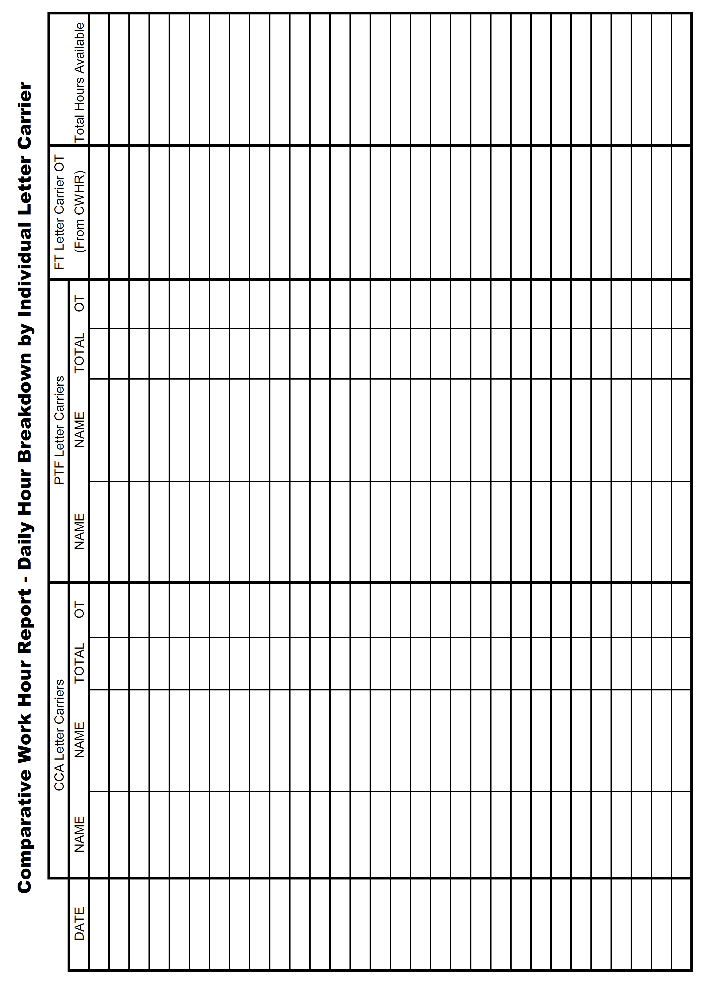

**National Association of Letter Carriers**



**Request for Information**

To: ________________________ Date _________________

(Manager/Supervisor)

_________________________________

(Station/Post Office)

Manager/Supervisor _______________________,

Pursuant to Articles 17 and 31 of the National Agreement, I am requesting the following information to investigate a grievance concerning a violation of Article 12:

1. Copies of TACS Employee Everything Reports for all letter carriers in the [**Installation name]** Installation for **[date]** to **[date]**.
2. Copies of Flash Last Four Weeks Report for the **[Installation name]** Installation for **[date]** to **[date]**.

I am also requesting time to interview the following individuals:

1. **[Name]**
2. **[Name]**
3. **[Name]**

Your cooperation in this matter will be greatly appreciated. If you have any questions concerning this request, or if I may be of assistance to you in some other way, please feel free to contact me.

Sincerely,

_________________________ Request received by: _____________________

Shop Steward

NALC Date: _________________

**National Association of Letter Carriers**



**Request for Steward Time**

To: ____________________________________ Date ___________________

(Manager/Supervisor)

____________________________

(Station/Post Office)

Manager/Supervisor _______________________,

Pursuant to Article 17 of the National Agreement, I am requesting the following steward time to investigate a grievance. I anticipate needing approximately _______________ (hours/minutes) of steward time, which needs to be scheduled no later than ________________ in order to ensure the timelines established in Article 15 are met. In the event more steward time is needed, I will inform you as soon as possible.

Your cooperation in this matter will be greatly appreciated. If you have any questions concerning this request, or if I may be of assistance to you in some other way, please feel free to contact me.

Sincerely,

__________________________ Request received by: _________________________

Shop Steward

NALC Date: ___________________